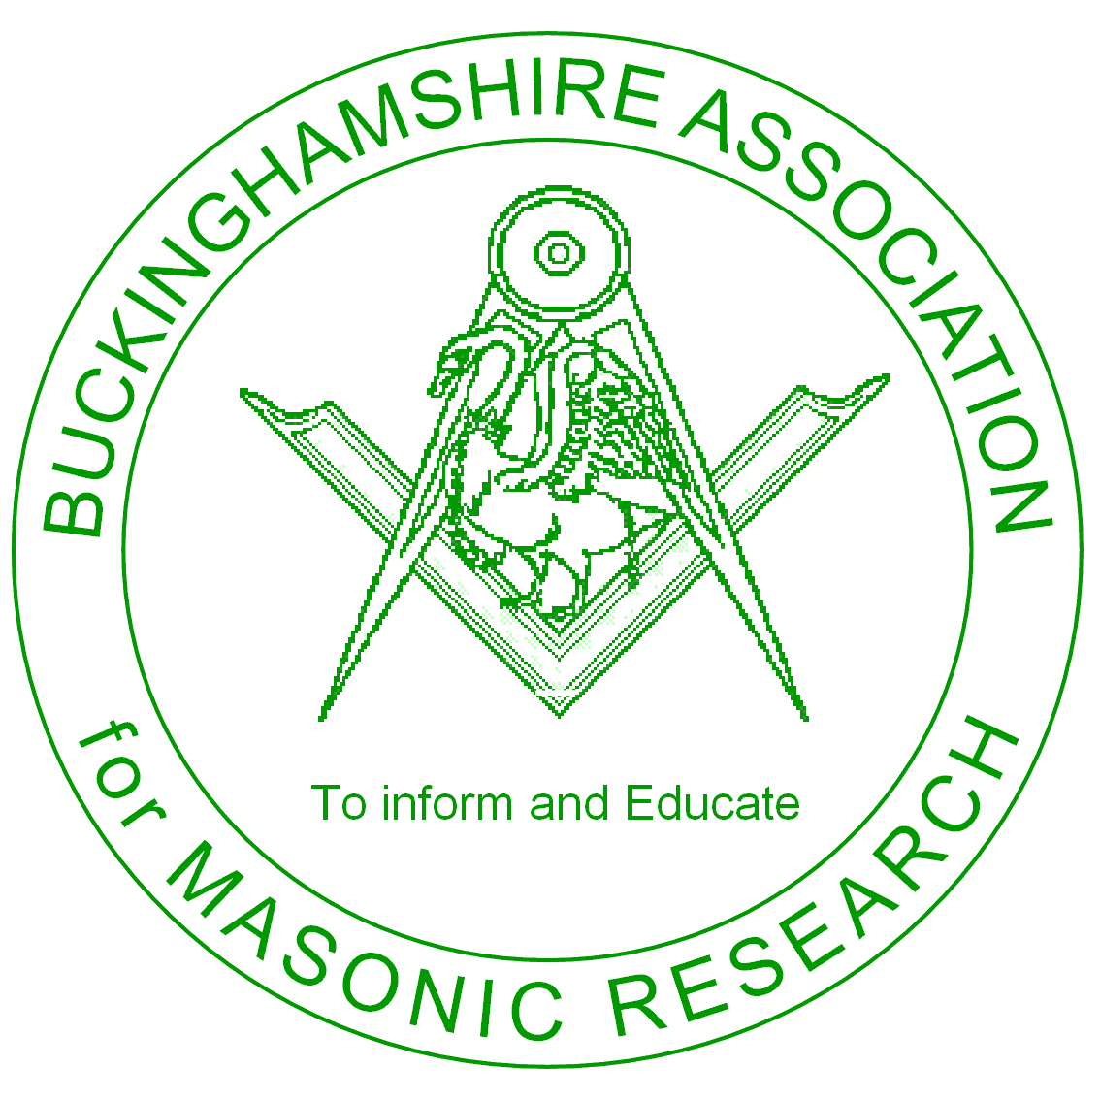

Buckinghamshire Association for Masonic Research

Information Paper No. 3

Recommended Reading for the
Masonic Researcher

BUCKINGHAMSHIRE ASSOCIATION FOR MASONIC RESEARCH

INFORMATION PAPER No. 3

RECOMMENDED READING FOR THE
MASONIC RESEARCHER

The newly made Mason is often left to his own devices and may feel that he should know more of the Institution he has joined. He feels that he wants to find out more about the Order he has entered, and could easily find himself wandering into a High Street Bookshop, in the hope he may find a book that tells him more. In most cases this is a waste of time, as most of these establishments prefer to stock the dramatic exposures or esoteric material that is far beyond the understanding of a newly made brother.

Before taking this step he must first decide which aspect of Freemasonry holds the greater interest and where he wishes to extend his researches. The subject of Freemasonry can usually be divided under the following headings: -

- Ritual
- History
- Reference & handbooks
- Side Orders
- Longer term reading and Study

- Ritual
These books are not recommended at first unless the new Brother has rapidly gone through his three degrees in Craft Masonry but they can be obtained thereafter and beyond for some of the recognised Masonic Orders. Details of Web Sites are listed in this Information Paper to assist

More recently a series of short books by the Rev Neville Barker-Cryer have been produced and are available from those bookshops/online shops listed overleaf.

What Do You Know About Ritual?
I Just Didn’t Know That
Did You Know This Too?

2. History
There has been much written about the history of Freemasonry, some very factual indeed. In this category would be placed the following;

- The Freemason’s Pocket Reference Book (very rare these days)
- The Craft – A History of English Freemasonry (John Hamill)
- History of Grand Lodge 1717 – 1967 (UGLE)
- The Freemason At Work (Harry Carr)
- The Collected Prestonian Lectures (5 volumes in all)

3 Reference & Handbooks
These provide information about specific Officers or about a particular degree in Freemasonry. Typically they would cover the role of Lodge Officers leading to and after the Chair so Officials such as the Secretary, Treasurer, Tyler and the Director of Ceremonies are described in detail

- Side Orders
The new made Mason often learns that other “degrees” are spoken of such as Mark, Royal Ark Mariners, The Holy Royal Arch, Rose Croix, Knights Templar and many more. Most Masonic Bookshops will stock books on these and other Orders that may appeal to the enquiring mind.

A very interesting book explaining the qualification and workings of a great number of the other Orders is “Beyond the Craft” by Keith B. Jackson and is again, available from any masonic regalia shop.

- Further Reading and Study
Once the new made Mason becomes confident and begins a deeper learning then he can certainly become a member of our own Provincial Research Association, Buckinghamshire Association for Masonic Research (BAMR). They meet throughout the year as well as having the Annual General Meeting and Papers’ Day where you can hear some very interesting talks on Freemasonry. Membership is just £8.00 per year, which includes a copy of their Annual Transactions as well as providing a great chance of meeting other like-minded brethren and represents excellent value for money

There is also the Quatour Coronati Lodge No. 2076, the Premier Lodge of Masonic Research in the world. You can join its Correspondence Circle as a Master Mason for £28.00 per year, which entitles you to receive their summonses, attend their meeting and, once a year, receive a copy of their Transactions. This is a must for the committed Masonic historian who wishes to study more deeply. QC also has over 120 of their Ars Quatour Coronatum (AQC) on CD Rom as an alternative

Useful Links and Web Sites
United Grand Lodge of England www.ugle.org.uk
Provincial Grand Lodge www.buckspgl.org
Provincial Grand Chapter www.bucksroyalarch.org
Lewis Masonic www.lewismasonic.com
Toye Kenning & Spencer www.toye.com
Letchworth’s (UGLE Shop) www.letchworthshop.co.uk
Quatour Coronati Correspondence www.quatourcoronati.com

Other Tips
Do not forget to look at what you may have already. Your Book of Constitutions that should have been given to you on your Initiation, together with two booklets –
1. Information for the Guidance for Members of the Craft and
2. Information about Masonic Charities.

Also, and most importantly, the Province of Buckinghamshire produces a Masonic Directory annually, usually issued at the end of January each year, which contains some very useful information about the Province and Freemasonry in general, and is a marvellous source of information local Freemasonry and Lodges. A copy can be obtained from the Provincial Grand Secretary at a cost of £5.00

In the Province many of the Centres have a library of Masonic books, papers and material for the benefit of those undertaking research. Finally, there are other web sites that offer both new and second hand books on Freemasonry, notably ABE books, Amazon and e-bay. Just enter Freemasonry onto their respective web sites.

March 2013

