Talk on:

The Knights Templar history and the current Masonic Knight Templar and Malta Degree

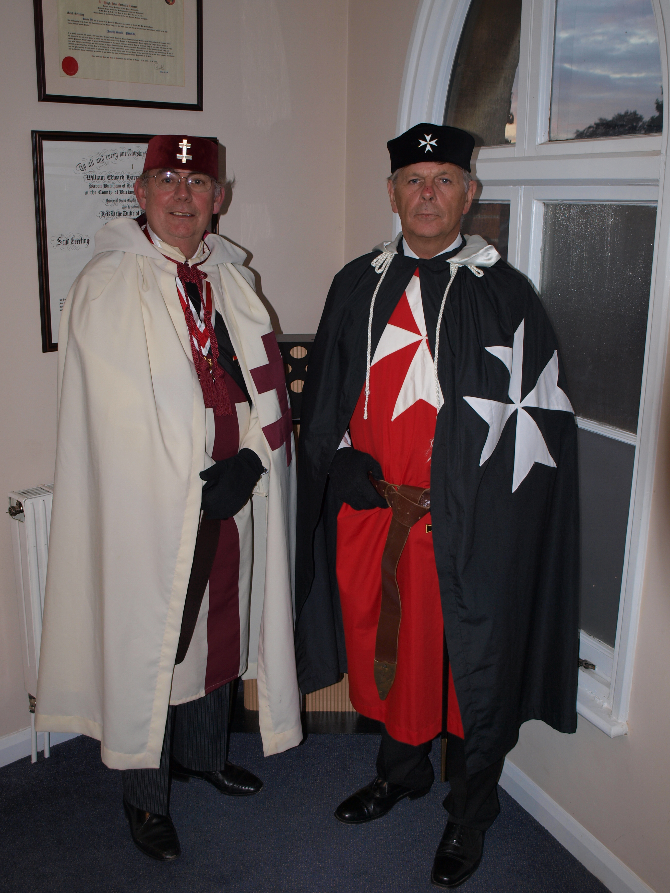
A talk on the Knight Templar history and the current Masonic Knight Templar and Malta Degree is to be given by Bob Chevin and Bernard Frow at the Aylesbury Chapter No. 4534 meeting on 22nd October 2009, at the Masonic Hall, Ripon Street, Aylesbury.

For more information contact Mick White – Scribe E MIKEJWHITE100@aol.com

Both speakers are members of the Buckinghamshire Association for Masonic Research (BAMR) www.bamr.co.uk

This talk was previously given in Beaconsfield in July to the Marlow Summer L.o.I. and was very well received, as the report below indicates.
When you organise these things, you never really know how they're going to turn out. Despite total confidence in all concerned, the nagging finger of doubt wakes you in the wee hours (at least I think that's what it was) and plays on your mind. Will the speakers turn up? Will their Papers be interesting? Will they be delivering them to an empty house? Will the bar have enough beer?

Brethren of Summer LoI... last night was an absolutely incredible evening. What a resounding success! I'm pretty sure that 33 is a record turn out, boy we rocked!

The very sight of our 2 speakers in the full regalia of the Knights Templar and Knight of Malta was quite stunning. Their Papers struck the right balance of the factual history of the Order (from inception, through the Crusades, to their bloody demise on Friday 13th), and how the modern-day Masonic Degree is organised and how we can be a part of it. Fascinating stuff.

May I formally proffer my profound thanks to Bernard Frow, Bob Chevin, Brethren of Summer LoI, and Nick (Beaconsfield Manager) for coming together to make such a worthwhile event happen. Words cannot fully convey how impressed I was by the whole evening, thank you.
Peter Bennett.

